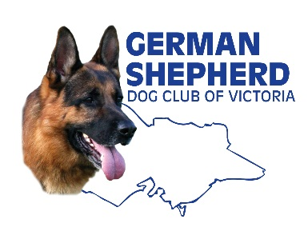

GERMAN SHEPHERD DOG CLUB OF VICTORIA
INCORPORATED
ABN: 78 395 029 707 Reg. No. A0018463W

Application for Approved Listing with the GSDCV Inc. Rehoming Service

The German Shepherd Dog Club of Victoria acts as a REFERRAL point for people wishing to rehome an adult dog and for people offering a home to an adult dog. In the majority of cases the Club has not seen the dog, knows little of its background and give no warranty as to its suitability for rehoming, its health status, vaccination status or its temperament. The Club simply acts as a point of contact.

There will be an administrative charge of $50.00 for all rehomed dogs. However under no circumstances does the German Shepherd Dog Club of Victoria offer any warranty or guarantee with these dogs.

Your name: _____________________________________________________________________________________
Phone: (H)________________________ (M) ____________________ email:___________________________________
Address: ___________________________________________________________________________________
_______________________________________________________________ Postcode: ______________________
Details of the Dog for Re Homing
Dogs Pedigree Name: _____________________________________________________________________________
Dogs Pet Name: _________________________________________________________________________________
Sex: M / F Age: ________________ Colour: _____________________
Date Last Vaccinated: _____________________________ Date Last Wormed: _______________________
Spayed/Neutered: Y / N Microchip number: _______________________________________
Why do you need to rehome your dog?
_______________________________________________________________________________________________
______________________________________________________________________________________________

Please provide the name, address and contact details of your current Veterinary Clinic.
_______________________________________________________________________________________________
Does your dog have any current medical conditions (eg eczema, arthritis, etc)?
_______________________________________________________________________________________________
Has your dog had any medical conditions in the past?
_______________________________________________________________________________________________

Is your dog accustomed to children? If yes, what age range?
______________________________________________________________________________________________
Are there any other dogs/pets at home?
_______________________________________________________________________________________________
How does your dog react around other dogs eg when out walking?
______________________________________________________________________________________________
How would you describe your dog - eg outgoing, timid, confident, excitable?
_______________________________________________________________________________________________
Is your dog used to traveling in the car?
_______________________________________________________________________________________________
What else would you like to tell us about your dog?
______________________________________________________________________________________________

_______________________________________________________________________________________________

_______________________________________________________________________________________________

I/We declare that all the information provided above is true and correct.

SIGNED: _____________________________________________ Date: ____________________

SIGNED: ____________________________________________ Date: _____________________

Submit this form to rehoming@gsdcv.org.au or
post to GSDCV Rehoming PO Box 397 Ashburton 3145
Include a photo if possible.

Payment: the GSDCV charges an administration fee of $50.00 for each dog surrendered. Payment may be made by direct deposit to
GSDCV Inc. BSB: 083-004 Account No 48-072-4293, or
by cheque or money order payable to GSDCV Inc .
Posted to Rehoming GSDCV PO Box 397 Ashburton 3147

If you have any queries contact rehoming@gsdcv.org.au or ring Judy on 03 9796 9842

